VINH HUNG PRIMARY SCHOOL  ---------***-- --------  Full name: .................................................  Class: 3 ..... |  |  | THE FIRST TERM TEST  ENGLISH - GRADE: 3  School year: 2021 - 2022  (Time: 35 minutes)
Skill | Listening | Reading |  | Writing | Speaking | Total
Mark
Remark

PART I: LISTENING.
Question 1: Listen and number. (1 point)
a | 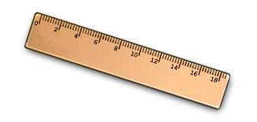b | c | 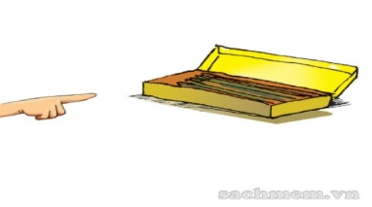d

Question 2: Listen and tick. (1 point)
1. A. |  | B. | 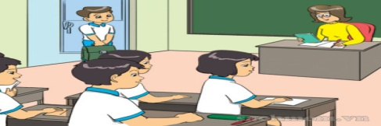
2. A. | 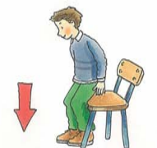 | B. |  | 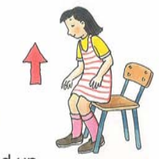
3. A. |  | B.
4. A. | 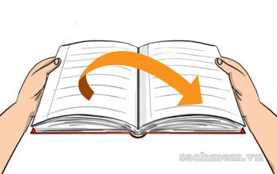 | B.

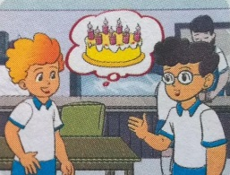
Question 3. Listen and draw the line. (1 point)

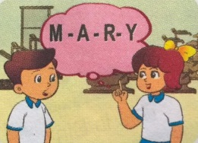
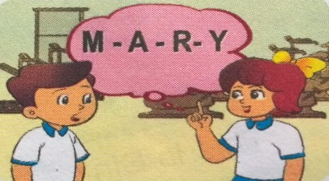
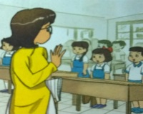
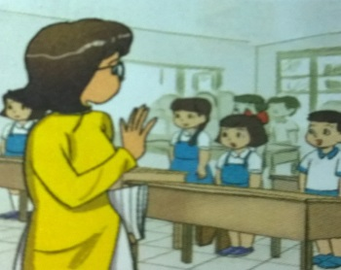
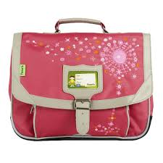
1
2
4
3

Question 4. Listen and write T (True) or F (False). (1 point)
1. That’s a pencil.

2. Hello, Linda. This is my friend, Hoa.

3. May I go out?

4. Sit down, please.

PART II: READING AND WRITING.
Question 5. Read and match. (1 point)

1. Hello, Nam |  | a. L-I-N-D-A.
2. How old are you, Mary? |  | b. My name’s Tony.
3. What’s your name? |  | c. Hi, Peter.
4. How do you spell your name? |  | d. I’m eight.
1. …. 2. …. 3. …. 4. ….

Question 6. Read and tick (Yes) or (No)

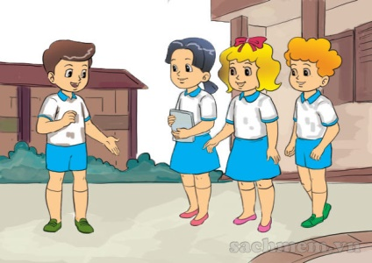 |  | Hello. My name’s Nam. I'm eight years old. I'm in class 3A. This is my best friend Mai. She is eight years old too. Here are Peter and Linda. Peter is seven and Linda is nine. They're my friends too.
 |  |  | Yes | No
 | 1. Nam is eight years old.
 | 2. His best friend is Linda.
 | 3. Linda is ten years old.
 | 4. Peter and Linda are Nam’s friends.

Question 7: Look at the pictures and write the words (1 point)
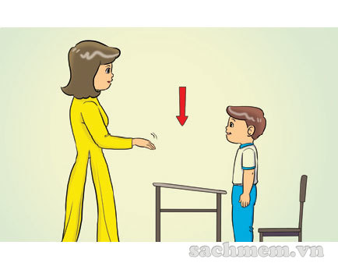 | 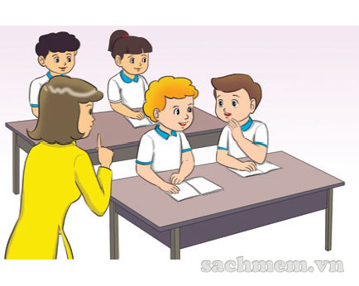
1. ……….…… down. | 2. Don’t .........................

3. It is a ……….…… | 4. It is a .........................

Question 8: Reorder the words to make sentences.(1 point)
1. name / is / What / your/ ?
--------------------------------------------------------------------------------------
2. to / you / Nice / meet / .
---------------------------------------------------------------------------------------
3. old / I’m / years / eight /.
---------------------------------------------------------------------------------------
4. spell / do / How / your / you / name / ?
---------------------------------------------------------------------------------------

-------------------THE END----------------------

GV coi:……………………. GV chấm: …………………..

KEYS TO TEST- GRADE 3 – 1st TERM

PART 1: LISTENING (4 points)
Question 1. Listen and number . (1point)
1. A | 2. D | 3. C | 4. B
1. This is my friend, Mai. 2. That’s a pencil case.
3. I like hide - and - seek. 4. It’s a ruler.

Question 2. Listen and tick. (1point)
1. B | 2. A | 3. B | 4. B
1. That’s my classroom.
2. May I sit down? Yes, you can.
3. This is my friend, Mai.
4. Close your book, please.

Question 3. Listen and draw the line. (1point)
1. A; How old are you?. 2. A: How do you spell your name?
B: I’m seven years old. B: M – A – R – Y.
3. This is my pen. 4. My school bag is pink.

Question 4: Listen and write T (true) or F (fall). (1 point)
1. F | 2. T | 3. T | 4. F
1. This is a pen. 2. Hello, Linda. This is my friend, Hoa.
3. May I go out? 4. Stand up, please!

PART 2: READING AND WRITING.

Question 5. Read and match. 1 point)
1. C | 2. D | 3. B | 4. A

Question 6. Read and tick (Yes) or (No). (1 point)
1. V | 2. X | 3. X | 4. V

Question 7. Look and write. (1 point)
1. Sit | 2. talk | 3. book | 4. pen

Question 8: Order the words. (1point)
1. What is your name? 2. Nice to meet you.
3. I’m eight years old. 4. How do you spell your name?

-------------------------------------------------------------

