VINH HUNG PRIMARY SCHOOL  ---------***----------  Full name: .................................................  Class: 5 ..... |  |  | THE FIRST TERM TEST  ENGLISH - GRADE: 5  School year: 2021 - 2022  (Time: 35 minutes)
Skill | Listening | Reading and writing |  | Speaking | Total
Mark
Remark
PART I: LISTENING
Question 1: Listen and number. (1 point)
a. | 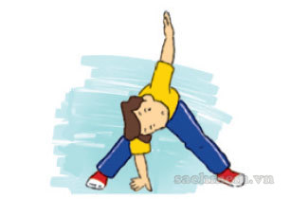  b. | 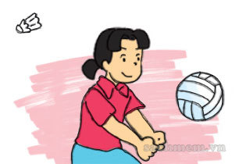  c. | 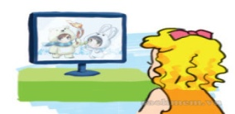  d.

Question 2: Listen and circle. (1 point)
- What are you reading? - I’m reading _______________________.
A. Snow White and the seven Dwarfs. B. The Story of Mai An Tiem.
- What is he reading? - He is reading _____________________.
- a comic book. B. a fairy tale.
- What’s Tam like? - She’s_____________________________.
- Kind B. gentle
- What’s the main character? – He’s______________________.
- Snow White B. Aladdin

Question 3. Listen and tick the correct picture. (1 point)
1.a 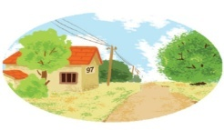 | b. 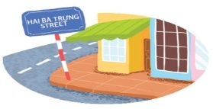 | c. 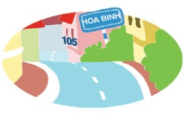
2.a | b. | c.
3.a | b. | c.
4. a 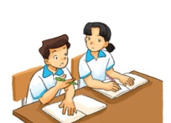 | b. 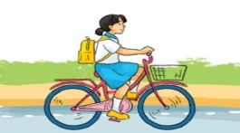 | c. 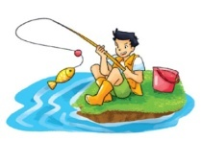

Question 4. Listen and match. (1 point)
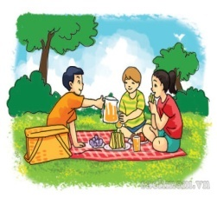
B
A

4
3
2
1

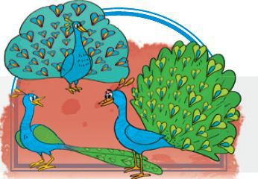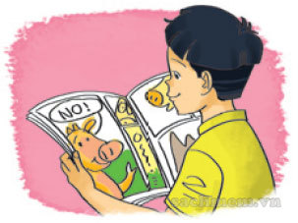
C
D

PART II: READING AND WRITING
Question 5: Look and write the correct words.(1point)
 | 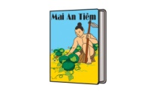 | 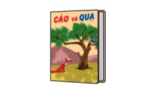 |  | 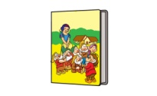
Doraemon | The Story of Mai An Tiem | The Fox and the Crow |  | Snow White and the Seven Dwarfs
1. It’s a story about an animal and a bird. |  |  | _____________________
2. It’s a fairy tale about a princess and seven short men. |  |  | _____________________
3. It’s a story about a Vietnamese hard-working man. |  |  | _____________________
4. It’s a Japanese story about a magic cat. |  |  | _____________________

Question 6: Look at the pictures. Read and write one word for each gap. (1point)
1. | I invited some of my friends to the _____________.

2. | We ate cakes, fruit and drank fruit ______________.

3. | We sang and ________________ happily.
4. | She went to her hometown by____________________.

Question 7: Reorder the words to make sentences.(1 point)
1. did/ you/ What/ at/ see/ zoo/ the/ ?
....................................................................................................................................
2. can/ water/ They/ with/ spray/ trunks/ their/.
....................................................................................................................................
3. borrow/ the/ May/ book/ I/ ?
....................................................................................................................................
4. likes/ reading/ in/ She/ fairy tales/ free time/ her/.
....................................................................................................................................
Question 8: Read and tick (V) True or False (1 point)
Vy likes English very much. At school, she has English four times a week. She often speaks English with her classmates. Sometimes, she talks with her foreign friend, Amy. They are happy because they can understand each other. Vy usually reads English comic books in her free time. At home, she practises listening by watching cartoons on TV. Vy wants to learn English well. She thinks English is necessary for her future.
 | True | False
1. Vy’s favourite subject is English.
2. She has English every day.
3. Amy can understand Vy’s English.
4. Vy usually reads comic books to practise listening.

-------------------THE END----------------------

GV coi:……………………. GV chấm: …………………..

VINH HUNG PRIMARY SCHOOL  ---------***---------- | THE FIRST TERM TEST  ENGLISH - GRADE: 5  School year: 2021 - 2022  (Time: 5 minutes)

PART III: SPEAKING (5 minutes)
Part 1: Getting to know each other (0,25point)
1. What’s your full name?
2. What day is it today?
3. What would you like to eat/ drink?
Part 2: Talking about a familiar object (0,25 point)
Give some story book and ask some question
1. What are you reading?
2. What is he/ she like?
3. Who is the main character?

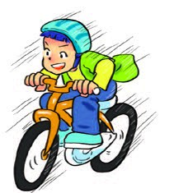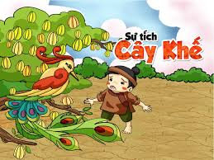

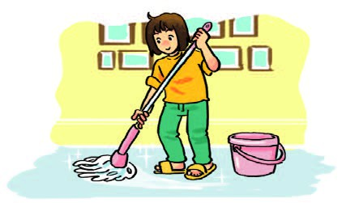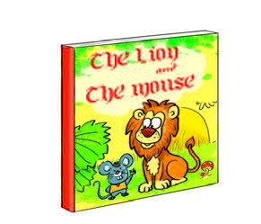

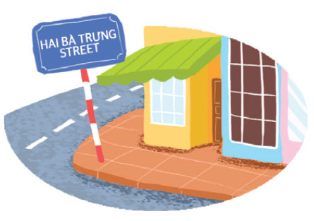

Part 3: Describing the picture (1 point)
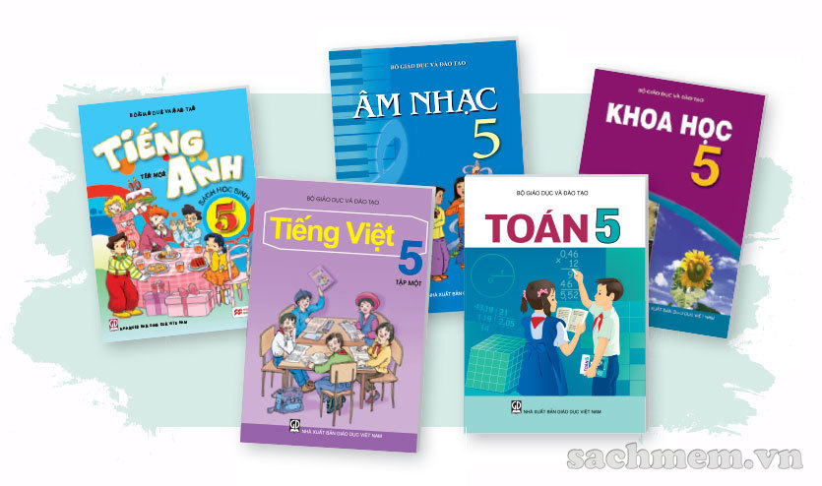

1. What subjects do you have today?
2. Do you like English? Why/ why not?
3. What’s your favorite subject?

-------------The end-------------

KEYS TO TEST- GRADE 5 – 1st TERM

PART 1: LISTENING (4 points)
Question 1. Listen and number . (1 point)
1. b | 2. c | 3. d | 4. a
- A: What do you do in the morning?
B: I usually do morning exercise.
- A: What are you going to do on Sports Day?
B: I’m going to play badminton.
A: I like badminton. Let’s play it together.
- A: How do you practise reading, Nam?
B: I read English book.
- A: How do you practise listening, Linda?
B: I watch English cartoons on TV.
Question 2. Listen and circle. (1 point)
1. B | 2. A | 3. A | 4. B
- What are you reading? - I’m reading The story of Mai An Tiem.
- What is he reading? - He is reading a comic book.
- What’s Tam like? - She’s kind.
- What’s the main character? – He’s Aladdin.

Question 3. Listen and circle the correct picture. (1 point)
1. B | 2. C | 3. A | 5. B
- A: What’s your address?
B: It’s 75, Hai Ba Trung Street.
- A: When will we explore the caves, Dad?
B: Not now, we’ll do it later.
A: Oh…..ok. Then I’ll go for a swim in the sea.
B: Good idea. Your mum and I will go for a swim, too.
- A: What are you doing?
B: I’m practicing for Sports Day.
A: Are you going to play basketball on that day?

B: Yes, I am.
- A: How do you go to school, Mai?

B: She rides a bike.
Question 4: Listen and match. (1 point)
1. B | 2. D | 3. C | 4.
- A: Where did you go on holiday?
B: I went to Hoi An Ancient Town.
- A: Why do you learn English?
B: Because I want to read English comic books.
- A: What did you see at the zoo?
B: I saw peacocks.
- A: Did you go on a picnic?
B: Yes, I did.

PART 2: READING AND WRITING.
Question 5. Look and write. (1 point)
1. The Fox and the Crow.
2. Snow White and Seven Dwarfs.
3. The Story of Mai An Tiem.
4. Doraemon.
Question 6. Look at the pictures. Read and write one word for each gap. (1 point)
1. party | 2. juice | 3. danced | 4. underground
Question 7: Reorder the words to make sentences. (1point)
1. What did you see at the zoo?
2. They can spray water with their trunks.
3. May I borrow the book?
4. She likes reading fairy tales in her free time.
Question 8. Read and tick(V) True or False. (1 point)
1. T | 2. F | 3. T | 4. F

-------------------------------------------------------------

